Use Cases Description
UC2- Booking Room Management

For

Meeting Room
Booking System
(MRBS)

Prepared by K15T1-Team11
Van Lang University
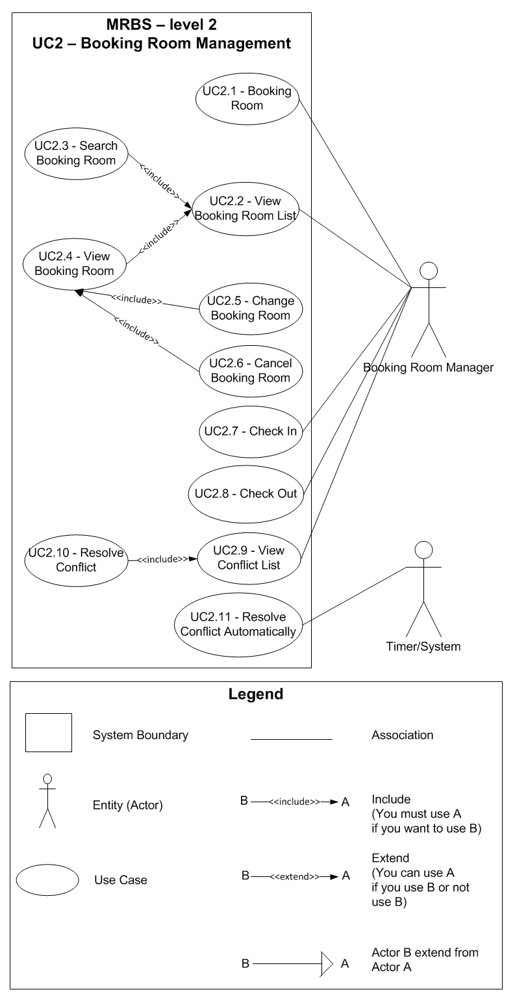
Table of Contents
UC2.1 – Booking Room 4
UC2.2 – View Booking Room List 5
UC2.3 – Search Booking Room 5
UC2.4 – View Booking Room 6
UC2.5 – Change Booking Room 7
UC2.6 – Cancel Booking Room 8
UC2.7 – Check In 9
UC2.8 – Check Out 10
UC2.9 – View Conflict List 10
UC2.10 – Resolve Conflict 11
UC2.11 – Resolve Conflict Automatically 12

UC2.1 – Booking Room
ID | UC2.1
Name | Booking Room
Author | Son Dang | Modify by | Tam Do
Date | 06/18/12 | Update | 07/04/12
Actor | Booking Room Manager
Description | User can create a new booking room
Precondition | User signed in system by Booking Room Manager’s account
Post condition: | System create a new booking room into database
Main flow: | 1. User press “Đặt phòng” button  2. System show a new dialog “Đặt phòng họp”  3. System show new “Mã đặt phòng”, “Ngày đặt phòng”; “Giờ đặt phòng”  4. User fill in the form  5. User press “Đồng ý” button  6. System check the valid of information (BR2.1.01; BR2.1.02; BR2.1.03; BR2.1.04)  7. System check the valid of information with existing data in database (BR2.1.05)  8. System save a new booking room into database  9. System show announcement that “Đăng ký đặt phòng thành công”
Alternative flow: | After step 4 of main flow:  5. User press “Hủy” button  6. System turn off dialog “Đặt phòng họp”
Alternative flow: | After step 6 of main flow (BR2.1.01):  7. System show announcement that “Các thông tin có (*) không được để trống” with “OK” button
Alternative flow: | After step 6 of main flow (BR2.1.02; BR2.1.03; BR2.1.04):  7. System show announcement that “Thông tin nhập vào không hợp lệ” with “OK” button
Alternative flow: | After step 7 of main flow (BR2.1.05):  8. System show announcement that “Đơn đặt phòng này trùng giờ/địa điểm với đơn đặt phòng đã được duyệt, vui lòng thử lại” with “OK” button
Exception :
Includes:
Priority: | Very High
Business rules: | BR2.1.01 – Required field not accept null: borrower information; “Mã đặt phòng”; “Tên phòng”; “Giờ bắt đầu”; “Giờ kết thúc”  BR2.1.02 – “Giờ bắt đầu” not accept more than 5 characters, and space between them; accept from “7:00” to “16:30” (except from “12:00” to “13:00”)  BR2.1.03 – “Giờ kết thúc” not accept more than 5 characters, and space between them; accept from “7:30” to “17:00” (except from “12:00” to “13:00”)  BR2.1.04 – “Giờ kết thúc” must bigger than “Giờ bắt đầu” at least 30 minutes  BR2.1.05 – Had a booking that approved existing in system
Mockup screen

UC2.2 – View Booking Room List
ID | UC2.2
Name | View Booking Room List
Author | Tam Do | Modify by
Date | 07/04/12 | Update
Actor | Booking Room Manager
Description | User can view a list of booking room for today
Precondition | User signed in system by Booking Room Manager’s account
Post condition: | System shows all booking room for today
Main flow: | 1. User press “Trang chủ” tab  2. System show a list of booking room for today (default)
Alternative flow:
Exception :
Includes:
Priority: | Normal
Business rules:
Mockup screen

UC2.3 – Search Booking Room
ID | UC2.3
Name | Search Booking Room
Author | Son Dang | Modify by | Tam Do
Date | 06/18/12 | Update | 07/04/12
Actor | Booking Room Manager
Description | User can search booking room that has not checked out by name, date or room
Precondition | User signed in system by Booking Room Manager’s account  User staying at “Trang chủ” form
Post condition: | System search the results
Main flow: | 1. User choose way to search “Theo mã người mượn”  2. User choose  3. User press “Tìm” button  4. System search and show list of booking room by code borrower from database (BR2.3.01)
Alternative flow: | 1. User choose way to search “Theo ngày”  2. User choose date that want to search  3. System search and show list of booking room of all room by date from database (BR2.3.01)
Alternative flow: | After step 3 of alternate flow 1:  4. User choose a room that want to search  5. System search and show list of booking room by room by date from database (BR2.3.01)
Exception :
Includes:
Priority: | Very High
Business rules: | BR2.3.01 – Only show a list of booking room with status null; “Đã duyệt”; “Đang mượn”
Mockup screen

UC2.4 – View Booking Room
ID | UC2.4
Name | View Booking Room
Author | Son Dang | Modify by | Tam Do
Date | 06/18/12 | Update | 07/04/12
Actor | Booking Room Manager
Description | User can view one booking room that has not checked out
Precondition | User signed in system by Booking Room Manager’s account  User staying at “Trang chủ” form  User searching a list of booking room that want to view
Post condition: | System view a detail booking room
Main flow: | 1. User double click into booking room that want to view  2. System show new dialog “Thông tin đặt phòng”  3. System show a detail booking room that user choose  4. System check the status of booking (BR2.4.01)
Alternative flow:
Exception :
Includes:
Priority: | Normal
Business rules: | BR2.4.01 – Unable “Đổi phòng” button if status is “Đang mượn”
Mockup screen

UC2.5 – Change Booking Room
ID | UC2.5
Name | Change Booking Room
Author | Son Dang | Modify by | Tam Do
Date | 06/18/12 | Update | 07/04/12
Actor | Booking Room Manager
Description | User can change one booking room that has not checked in
Precondition | User signed in system by Booking Room Manager’s account  User staying at “Trang chủ” form  User viewing a detail booking room
Post condition: | System change a booking room and save into database
Main flow: | 1. User press “Đặt phòng” button  2. System show announcement that “Bạn có chắc chắn muốn thay đổi đơn đặt phòng này không?” with “Yes” and “No” button  3. User press “Yes” button  4. User edit a booking room information that accept to edit (BR2.5.01)  5. User press “Đồng ý” button  6. System check the valid of information (BR2.5.02; BR2.5.03; BR2.5.04; BR2.5.05)  7. System check the valid of information with existing data in database (BR2.5.06)  8. System save a booking room information that edited in database  9. System show announcement that “Thay đổi thông tin đặt phòng thành công” with “OK” button
Alternative flow: | After step 2 of main flow:  3. User press “No” button  4. Nothing appear
Alternative flow: | After step 4 of main flow:  5. User press “Hủy” button  6. System restore all information before user edit
Alternative flow: | After step 6 of main flow (BR2.5.02):  7. System show announcement that “Các thông tin có (*) không được để trống” with “OK” button
Alternative flow: | After step 6 of main flow (BR2.5.03, BR2.5.04, BR2.5.05):  7. System show announcement that “Thông tin nhập vào không hợp lệ” with “OK” button
Alternative flow: | After step 7 of main flow (BR2.5.06):  8. System show announcement that “Đơn đặt phòng này trùng giờ/địa điểm với đơn đặt phòng đã được duyệt, vui lòng thử lại” with “OK” button
Exception :
Includes:
Priority: | High
Business rules: | BR2.5.01 – User can edit field: “Tên phòng”; “Ngày sử dụng”; “Thời gian bắt đầu”; “Thời gian kết thúc”; “Tìm nhanh” button; “Xác nhận” button  BR2.5.02 – Required field not accept null: “Tên phòng”; “Ngày sử dụng”; “Thờig ian bắt đầu”; “Thời gian kết thúc”  BR2.5.03 – “Thời gian bắt đầu” not accept more than 5 characters, and space between them; accept from “7:00” to “16:30” (except from “12:00” to “13:00”)  BR2.5.04 – “Thời gian kết thúc” not accept more than 5 characters, and space between them; accept from “7:30” to “17:00” (except from “12:00” to “13:00”)  BR2.5.05 – “Thời gian kết thúc” must bigger than “Thời gian bắt đầu” at least 30 minutes  BR2.5.06 – Had a booking that approved existing in system
Mockup screen

UC2.6 – Cancel Booking Room
ID | UC2.6
Name | Cancel Booking Room
Author | Son Dang | Modify by | Tam Do
Date | 06/18/12 | Update | 07/04/12
Actor | Booking Room Manager
Description | User can cancel one booking room that has not checked in
Precondition | User signed in system by Booking Room Manager’s account  User staying at “Trang chủ” form  User viewing a detail booking room
Post condition: | System cancel a booking room and save into database
Main flow: | 1. User press “Hủy phòng” button  2. System show announcement that “Bạn có chắc chắn muốn hủy đơn đặt phòng này không?” with “Yes” and “No” button  3. User press “Yes” button  4. System cancel this booking and save into database  5. System turn off dialog “Thông tin đặt phòng”
Alternative flow: | After step 2 of main flow:  3. User press “No” button  4. Nothing appear
Exception :
Includes:
Priority: | Normal
Business rules:
Mockup screen

UC2.7 – Check In
ID | UC2.7
Name | Check In
Author | Son Dang | Modify by | Tam Do
Date | 06/18/12 | Update | 07/03/12
Actor | Booking Room Manager
Description | User can check in one booking room that has approved booking
Precondition | User signed in system by Booking Room Manager’s account  User staying at “Trang chủ” form
Post condition: | System check in booking room and save into database
Main flow: | 1. User press “704A” or “706A” or “701C” button that room of borrower booking  2. User press “Nhận” button next to information of borrower “Người mượn tiếp theo”  3. System show announcement that “Bạn có chắc người mượn này nhận phòng chứ?” with “Yes” and “No” button  4. User press “Yes” button  5. System check in this booking and save into database  6. System change the current status of room  7. System show new dialog “Nhận phòng”
Alternative flow: | After step 3 of main flow:  4. User press “No” button  5. Nothing appear in form
Exception :
Includes:
Priority: | Very High
Business rules:
Mockup screen

UC2.8 – Check Out
ID | UC2.8
Name | Check Out
Author | Son Dang | Modify by | Tam Do
Date | 06/18/12 | Update | 07/03/12
Actor | Booking Room Manager
Description | User can check out one booking room that has checked in
Precondition | User signed in system by Booking Room Manager’s account  User staying at “Trang chủ” form
Post condition: | System check out booking room and save into database
Main flow: | 1. User press “704A” or “706A” or “701C” button that room of borrower booking  2. User press “Trả” button next to information of borrower “Người mượn hiện tại”  3. System show announcement that “Bạn có chắc người mượn này trả phòng chứ?” with “Yes” and “No” button  4. User press “Yes” button  5. System check out this booking and save into database  6. System change the current status of room  7. System show new dialog “Trả phòng”
Alternative flow: | After step 3 of main flow:  4. User press “No” button  5. Nothing appear in form
Exception :
Includes:
Priority: | Very High
Business rules:
Mockup screen

UC2.9 – View Conflict List
ID | UC2.9
Name | View Conflict List
Author | Tam Do | Modify by
Date | 07/03/12 | Update
Actor | Booking Room Manager
Description | User can view a list of conflict booking room
Precondition | User signed in system by Booking Room Manager’s account
Post condition: | System shows all conflict by room
Main flow: | 1. User press “Danh sách xung đột”  2. System show “Danh sách xung đột” tab  3. System show a list of conflict  4. User choose a conflict  5. System show a list of conflict booking of that conflict
Alternative flow:
Exception :
Includes:
Priority: | Very High
Business rules:
Mockup screen

UC2.10 – Resolve Conflict
ID | UC2.10
Name | Resolve Conflict
Author | Tam Do | Modify by
Date | 07/03/12 | Update
Actor | Booking Room Manager
Description | User can approve a conflict booking
Precondition | User signed in system by Booking Room Manager’s account  User staying at “Danh sách xung đột” form and viewing a conflict of booking room
Post condition: | System remove all conflict booking room in conflict that user choose  System save new change into database
Main flow: | 1. User choose conflict booking room that want to approve booking (BR2.10.01)  2. User press “Duyệt”  3. System save a approve booking into database  4. System remove that conflict with all conflict booking in this form  5. System show announcement that “Đã chấp nhận mã đặt phòng “….” Thành công” with “OK” button”
Alternative flow:
Exception :
Includes:
Priority: | Very High
Business rules: | BR2.10.01 – Choose only one booking room to approve booking
Mockup screen

UC2.11 – Resolve Conflict Automatically
ID | UC2.11
Name | Resolve Conflict Automatically
Author | Tam Do | Modify by
Date | 07/03/12 | Update
Actor | Timer/System
Description | Timer will calculate and resolve conflict every booking room and update to list of resolve conflict
Precondition | User signed in system by Booking Room Manager’s account  User create new booking room or change, cancel existing booking room
Post condition: | Timer will update to list of resolve conflict
Main flow: | 1. System calculate priority for every conflict booking room for new day (BR2.11.01)  2. System decide approve or not for every type of priority for list of conflict booking room (BR2.11.02)  3. System update list of resolve conflict in database (BR2.11.03)
Alternative flow:
Exception :
Includes:
Priority: | Very High
Business rules: | BR2.11.01 – Formula for calculate priority:  - Case 1: Booking before 3 days  - High priority: booking with confirmation of lecturer  - Medium priority: booking with no confirmation of lecturer  - Case 2: Booking after 3 days with nobody booking with High priority of Case 1  - Medium priority: booking with confirmation of lecturer  - Low priority: booking with no confirmation of lecturer  BR2.11.02 – Decide approve automatically  - Case 1: If nobody booking with High priority of Case 1 of BR2.11.01  - Not approve everything for this conflict  - Accept for user can create new booking for that room with conflict time  - Case 2: If Case 1 of BR2.11.01 have 1 booking with High priority  - Approve automatically for that booking  - Not accept for user create new booking for that room with conflict time  BR2.11.03 – Update list of resolve  - Case 1: If Case 1 of BR2.11.01 have 2 or more booking with High priority  - Update 2 or more conflict booking with High priority  - Case 2: Case 2 of BR2.11.01  - Update all conflict booking of this case
Mockup screen

